Bed & Breakfast

Reservation

and

Accounting System

Software Requirements Specification

30 August 2015

Michael Straughan

Lead Software Engineer

CMIS 330 6381

Software Engineering Principles and Techniques

Ronald McFarland

**1. Introduction**

This section gives a scope description and overview of everything included in this SRS document. Also, the purpose for this document is described and a list of abbreviations and definitions is provided.

## **1.1 Purpose**

The purpose of this Software Requirements Specification is to serve as a foundation to the software/system engineers, software developers, and testers who are working on the "B&B Reservation & Accounting System". It should give all parties the necessary information to design, develop, and test the software. It will also explain system interface and interactions within the software and with external sources. Finally, this is intended to be proposed to the customer for approval.

## **1.2 Scope**

The "B&B Reservation & Accounting System" is a software system that has two functions. First, it enables customers to make a reservation to stay at the facility by providing an electronic form to submit a reservation request. The system will handle all details for record keeping of customer data, customer credit card information, reservation details, and account balance details. The system will inform the customer of a successful reservation or inform them of an error, which requires the form information to be corrected and resubmitted for additional requests. The application platform is not specified, as this is a high-level system architecture and should be applicable to multiple platforms.

Second, the system will produce two report types for management. On a successful customer reservation, the system will provide to the management a reservation report containing all the customer and reservation detail. Second, on request from the management, the system will provide an operational report overviewing the payments received, expenses, and profit made. The system has access to this function through the various external databases it is connected to.

The goal of this software is to provide an electronic alternative to booking a reservation at this facility and to quickly provide feedback for a (un)successful reservation request. This software does not provide any additional functionality, such as tracking of customers who are checked in, costs associated with business/facility operations, or as a digital homepage for the operation.

The scope is limited in that it will only handle reservation details and using those details provides reports to the management.

## **1.3 Definitions, Acronyms, and Abbreviations**

**User** - Any person will interact with the software

**Customer** - The prospective user who will make a reservation within the software

**Manager/Management** - The user who will use the software to retrieve operational reports. This user might also be the contracting party for this software.

**Operational Reports** - A report produced by the software to display payment, expense and profit information. This information is pulled from the Accounting Database.

**Customer Database** - An external database that will record all customer information.

**Reservation Database** - An external database that will record all reservation information. This information is linked to the Customer Database entries.

**Accounting Database** - An external database that will record all transactional data, such as payment for services. This information is linked to the Customer Database entries for tracking payment made/due. Also, it keeps a record of total payment, expense and profit information for the business/facility.

**Business/Facility** - The entity that utilizes this system.

## **1.5 Overview**

# **2. General Description**

## **2.1 Product Perspective**

## **2.2 Product Functions**

## **2.3 User Characteristics**

## **2.4 General Constraints**

## **2.5 Assumptions and Dependencies**

# **3. Specific Requirements**

See the Appendix for the exact “Statement of Need” from the management, where the specific requirements were taken from.

## **3.1 External Interface Requirements**

### **3.1.1 User Interfaces**

### **3.1.2 Hardware Interfaces**

### **3.1.3 Software Interfaces**

### **3.1.4 Communications Interfaces**

## **3.2 Functional Requirements**

### **3.2.1 <Functional Requirement or Feature #1>**

3.2.1.1 Introduction

3.2.1.2 Inputs

3.2.1.3 Processing

3.2.1.4 Outputs

3.2.1.5 Error Handling

### **3.2.2 <Functional Requirement or Feature #2>**

…

## **3.3 Use Cases**

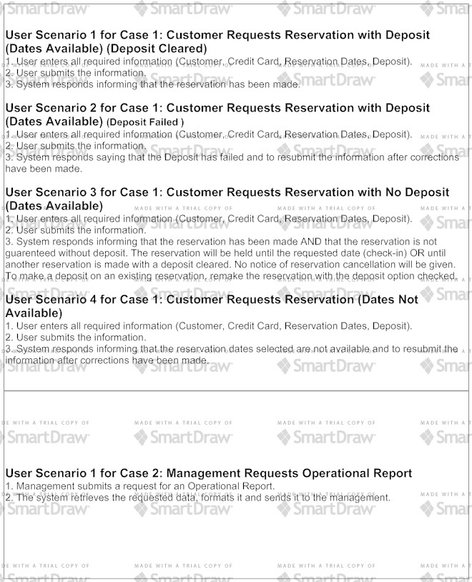

## **3.4 Classes / Objects**

## 

## **3.5 Non-Functional Requirements**

### **3.5.1 Performance**

### **3.5.2 Reliability**

### **3.5.3 Availability**

### **3.5.4 Security**

### **3.5.5 Maintainability**

### **3.5.6 Portability**

## **3.6 Inverse Requirements**

## **3.7 Design Constraints**

## **3.8 Logical Database Requirements**

## **3.9 Other Requirements**

# **4. Analysis Models**

The analysis models used are the State-Transition Diagram and the Data Flow Diagram. The State-Transition Diagram shows all the changes in state during a complete instance run of the system, shows the different state changes that push the system forward and finally shows all the possible end results of the software. These reflect the Use Cases and User Scenarios.

The Data Flow Diagrams show both Data Flow Diagram level 0 and Data Flow Diagram level 1. DFD 0 is also identical to the Architectural Context Diagram that breaks down the system into smaller subsystems and external input/output sources. DFD1 further breaks down the B&B Accounting and Reservation “black box” system into subsystems that show the flow of data throughout the program.

## **4.1 State-Transition Diagrams (STD)**

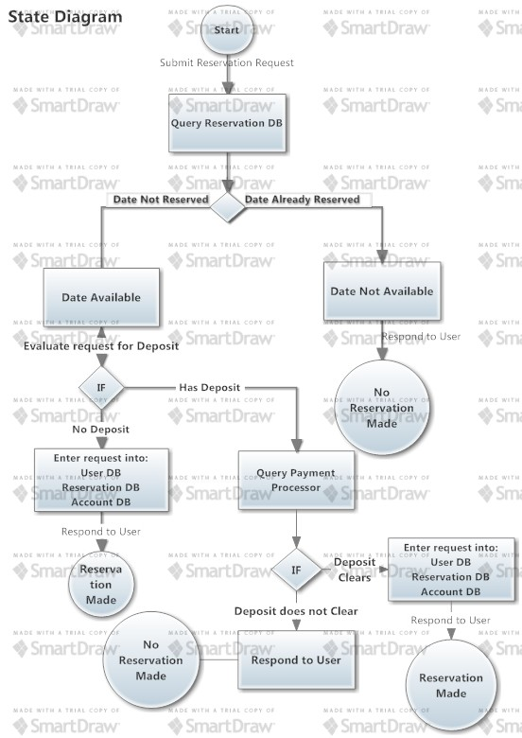

## **4.2 Data Flow Diagrams (DFD)**

# 

# **5. Change Management Process**

The process to make changes and update this SRS document will use the following process:

1. A request for change can only be made by the Management.
2. After request is submitted, a review of the SRS document will take place with the Management and all involved contractor parties.
3. Once the nature of the change has been discussed, an updated version of the SRS will be created.
4. The SRS will be submitted back to the Management for review.
5. Repeat steps 2 through 4 as needed until both parties have agreed to the new changes.

# **A. Appendix**

This is the exact requirement “Statement of Need” from the Management:

*"John and Jane are starting a bed-and-breakfast (B&B) in a small New England town. They will have three bedrooms for guests. They want a system to manage the reservations and to monitor expenses and profits. When a potential customer calls for a reservation, they will check the calendar, and if there is a vacancy, they will enter the customer name, address, and phone number, dates, agreed upon price, credit card number, and room numbers. Reservations must be guaranteed by 1 day’s payment. Reservations will be held without guarantee for an agreed upon time. If not guaranteed by that date, the reservation will be dropped.”*